Английский язык 9-11 класс,

школьный этап (1 этап), 2020-2021 учебный год

Содержание
- LISTENING
- READING
- USE OF ENGLISH
- WRITING
- Keys
  - LISTENING
  - READING
  - USE OF ENGLISH
- Подсчёт баллов за все конкурсы
- Критерии оценивания раздела «Письмо»
- Audioscript (listening)

LISTENING
Time: 10 minutes
Аудиоплеер
06:05
09:40
Используйте клавиши вверх/вниз, чтобы увеличить или уменьшить громкость.

https://olimpiadnye-zadanija.ru/anglijskij-yazyk-9-11-klass-shkolnyj-etap-1-etap-2019-2020-uchebnyj-god/#_Toc26953714FirefoxHTML-308046B0AF4A39CB\Shell\Open\Command

(10 points) For items 1–10 listen to a man talking about a boy called Michael who crossed the Atlantic in a sailing boat and decide whether the statements 1–10 are TRUE according to the text you hear (A), or FALSE (B), or the information on the statement is NOT STATED in the text (C). You will hear the text twice.
- Michael Perham, a teenage boy from the south of England, became the only person to sail across the Atlantic alone.
- Michael started his voyage across the Atlantic when he was seven.
- The Cheeky Monkey is a 9-metre yacht which was designed for the cross-Atlantic voyage.
- During his voyage, Michael ate food which had been presented to him by a local supermarket.
- Burgers and crisps were the things Michael missed most during his voyage.
- One day during the trip, Michael’s father contacted him to say that a part of Michael’s boat was broken.
- Michael didn’t play his guitar during the trip.
- Once he managed to catch a flying fish which had jumped into his boat.
- Michael contributed a lot of money to the fund Children in Need.
- Michael and his father would like to do their next trip in bigger and faster boats.

READING
Time: 20 minutes
(15 points)
Read an extract from a novel and answer questions 1–15.
It would be simple enough to follow him. Roger was a man of habits, and even when his hours of work were irregular, he would still take his mid-day meal, whenever he did take it, at Percy’s. Miss Temple found an antique bookshop across the street where, as she was obliged to purchase something for standing so long watching through its window, she on impulse selected a complete four-volume Illustrated Lives of Sea Martyrs. The books were detailed enough for her to spend the time in the window, apparently examining the books, while actually watching Roger first enter and then, after an hour, exit alone, from the heavy doors across the street.
He walked straight back to his office in the Ministry courtyard. Miss Temple arranged for her purchase to be delivered to the Boniface, and walked back into the street, feeling like a fool. She had re-crossed the square before she convinced herself that she was not so much a fool as an inexperienced observer. It was pointless to watch from outside the restaurant because only from inside could she have discovered whether or not Roger dined alone or with others, or with which particular others — all important information.
She had a pretty good feeling that the crime she believed he had committed had no time connection with his working hours, which meant she was likely to learn nothing from observing his working day. It was after work that any real information would be gathered. Abruptly she entered a store whose windows were thick with all shapes of luggage, hampers, oilskins, lanterns, telescopes, and a large assortment of walking sticks. She left wearing a ladies’ black travelling cloak, with a deep hood and several well hidden pockets, opera glasses, a leather-bound notebook and an allweather pencil. Miss Temple then took her tea.
Between cups of tea and two cakes, she made entries in the notebook, summarising her plan and then describing the day’s work so far. That she now had a kind of uniform and a set of tools made everything that much easier and much less about her particular feelings, for tasks requiring clothes and supporting equipment seemed somehow more objective, even scientific, in nature. In keeping with this, she made a point to write her entries in a kind of code, replacing proper names and places with synonyms or word-play that hopefully would not be understood by anyone but herself.
Miss Temple left the tea shop at four o’clock, knowing Roger to leave usually at five, and hired a carriage. She instructed her driver in a low, direct tone of voice, after assuring him he would be well paid for his time, that they would be following a gentleman, most likely in another carriage, and that she would knock on the roof of the coach to indicate the man when he appeared. The driver nodded, but said nothing else. She took his silence to mean that this was a usual enough thing, and felt all the more sure of herself. When Roger appeared, some forty minutes later, she nearly missed him, amusing herself for the moment by peering through the opera glasses into nearby open windows, but a sudden feeling caused her to glance back at the courtyard gates just in time to see Roger, standing in the road with an air of confidence and purpose that took her breath away, flag down a coach of his own. Miss Temple knocked sharply on the roof of the coach and they were off.
The thrill of the chase, complicated by the nervousness of seeing Roger, was quickly lost when, after the first few turns, it became obvious that Roger’s destination was nowhere more interesting than his own home.
Task 1. Questions 1–7
In boxes 1–7 on your answer sheet, circle: A (TRUE) if the statement agrees with the information given in the text; B (FALSE) if the statement contradicts the information given in the text or if there is no information given in the text.
- Miss Temple took her time carefully selecting the four books which she bought in the antique bookshop.
- Her mistake resulted from her being pretty much a beginner in the field of surveillance.
- She bought a pair of glasses to read the books she had purchased in the antique bookshop.
- Miss Temple encrypted her notes so that nobody could understand them.
- She promised the driver extra money for his services.
- Miss Temple had to wait more than an hour for Roger to appear.
- Roger had committed a terrible crime at work.
Task 2. Questions 8–15
Choose option A, B, C or D which best fits according to the text. Circle the correct letter in boxes 8–15 on your answer sheet.
- Miss Temple thought it would be easy to follow Roger because
- A he always took a break at the same time.
- B his work schedule never changed.
- C he always ate lunch at a particular location.
- D she already knew the schedule of his working day.
- Miss Temple bought a book at the bookshop because
- A she suddenly felt like buying something.
- B she was forced to by the shop owner.
- C she wanted a way to pass the time.
- D she needed an excuse to stay there.
- What mistake did Miss Temple soon realise she had made?
A She had waited for Roger in the wrong place
B She needn’t have made a purchase at the bookshop
C She should have followed Roger back to the Ministry when she had had the chance
D She had re-crossed the square at the wrong place
- Miss Temple decided to follow Roger after work because
A she believed that was the time she could find out what she wanted to know.
B she couldn’t see what he was doing inside his office.
C she didn’t want to risk him seeing her outside his office.
D she had other, more important things to do during the working day.
- How did Miss Temple’s purchases make her feel about what she was doing?
A more determined
B less personally involved
C better prepared
D less confused
- The underlined word ‘this’ in the text refers to
A the driver’s silence.
B banging on the hood of the carriage.
C being asked to follow someone.
D paying drivers well for their time.
- When Roger left his office at about five o’clock, Miss Temple
A watched him through her new opera glasses.
B saw him just before he got into a carriage.
C had a sudden feeling of breathlessness.
D pretended to be looking into an open window.
- Miss Temple’s excitement at following Roger
A increased each time she caught sight of him.
B turned into boredom after a while.
C ended when her carriage started following him.
D disappeared when she realised where he was going.

USE OF ENGLISH
Time: 20 minutes
(20 points)
Task 1. Questions 1–10
For items 1–10, read the text below. Use the word given in capitals at the end of each line to form a word that fits in the space in the same line. There is an example at the beginning (0).
Example:
0 | IMPRESSION

BRITISH FOOD
Many people are under the (0) … that British food is awful. | IMPRESS
It is said to be (1) … and cooked badly, so the idea that Britain has some of the best restaurants in the world is | TASTE
usually met with roars of (2) … . | LAUGH
However, perhaps this is a little (3) … . | FAIR
There have been some wonderful (4) … in recent years. | IMPROVE
There are now many (5) … restaurants serving high quality | EXCITE
dishes that have been very (6) … prepared. Also, many British chefs now have Michelin stars, which are only awarded to the world’s very best chefs. | SKILL
A good (7) … of food is available these days, too. In other words, the food being served isn’t just French gourmet. | VARY
There has been a huge rise in the popularity of (8) … British dishes. Fortunately, gone are the days when the only things on the menu were boiled vegetables and stewed meat! | TRADITION
So, the next time you get a chance, be (9) … and try some real British food. You just might find it no longer deserves | ADVENTURE
its terrible (10) … . | REPUTE

Task 2. Questions 11–20
For items 11–20, complete the second sentence so that it has a similar meaning to the first sentence, using the word given. Do not change the word given. Use from three to five words. The number of words you should put in the gap is specified in each case. Do NOT use contracted forms. There is an example at the beginning (0).
Example: 0. “Let’s go to the cinema on Sunday,” said Ann.
wanted
Ann_____ _____ ____ ____ to the cinema on Sunday. (4 words)
0 | wanted us to go

- The professor said that his assistant had given away the secret formula.
ACCUSED
The professor ____ ____ ____ ____ ____ away the secret formula. (5 words)
- They say a multinational company owns this factory.
SAID
The factory ____ ____ ____ ____ ____ by a multinational company. (5 words)
- I think they did not plan this.
MIGHT
They ____ ____ ____ ____ this. (4 words)
- He will probably win the race.
LIKELY
He ____ ____ ____ ____ the race. (4 words)
- She woke up early so that she could catch the 5:30 train.
ORDER
She woke up early ____ ____ ____ ____ the 5:30 train. (4 words)
- Martin realised that he could never be an athlete.
BORN
Martin realised that he ____ ____ ____ ____ ____ an athlete. (5 words)
- The teacher advised him to study harder.
WERE
“If ____ ____ ____ , ____ ____study harder”, said the teacher. (5 words)
- They are launching a new product these days.
IS
A new product ____ ____ ____ these days. (3 words)
- There were very few guests at Paula’s wedding yesterday.
CAME
Hardly ____ ____ ____ ____ Paula’s wedding yesterday. (4 words)
- Our teacher demands that we hand in our homework regularly.
INSISTS
Our teacher ____ ____ ____ ____ ____ our homework regularly. (5 words)

WRITING
Time: 40 minutes
(15 points)
Write a short description of any monument in Moscow which is devoted to
World War II and recommend it to foreign tourists.
Write the name of the monument at the beginning on a separate line (words are not counted in this line). The monument should be real, not imaginary.
Remember to mention in your description:
- what the monument looks like;
- where the monument is located (area of Moscow);
- why you recommend it to foreign tourists.
Write 200–250 words.

Подсчёт баллов за все конкурсы
Listening. Максимальное количество баллов – 10. Задания проверяются по ключам. Каждый правильный ответ оценивается в 1 балл. За неверный ответ или отсутствие ответа выставляется 0 баллов.
Reading. Максимальное количество баллов – 15. Задания проверяются по ключам. Каждый правильный ответ оценивается в 1 балл. За неверный ответ или отсутствие ответа выставляется 0 баллов.
Use of English. Максимальное количество баллов – 20. Задания 1–20 проверяются по ключам. Каждый правильный ответ оценивается в 1 балл. За неверный ответ или отсутствие ответа выставляется 0 баллов. Орфография учитывается. Если допущена орфографическая ошибка в ответе, балл не начисляется. В заданиях 11–20 возможно расширение ключей (возможны дополнительные правильные варианты), эти задания необходимо проверять, имея перед глазами не только ключи, но и сами задания, чтобы не пропустить возможные правильные варианты, не указанные в ключах.
Writing. Максимальное количество баллов – 15. Задание оценивается по Критериям оценивания.
При подведении итогов баллы за все конкурсы суммируются.
Максимальное количество баллов за все конкурсы – 60.

Критерии оценивания раздела «Письмо»

Максимальное количество баллов – 15.
Внимание! При оценке «0» по критерию «Решение коммуникативной задачи» выставляется общая оценка «0».
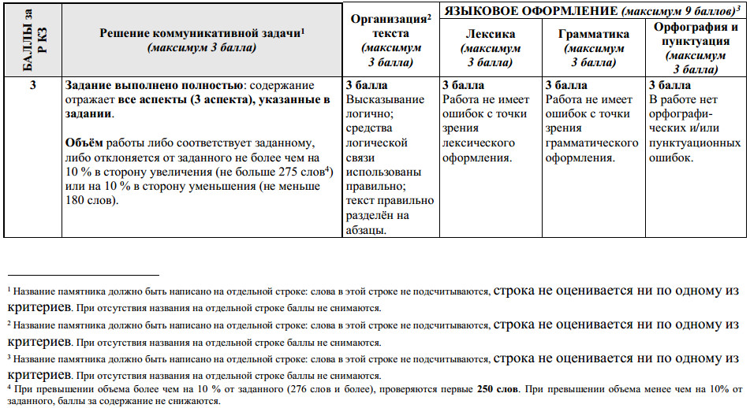

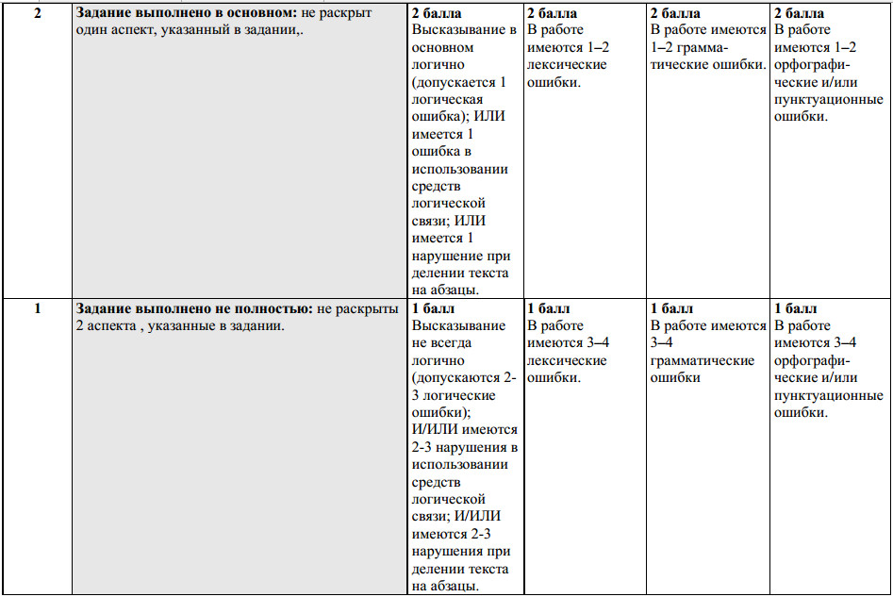

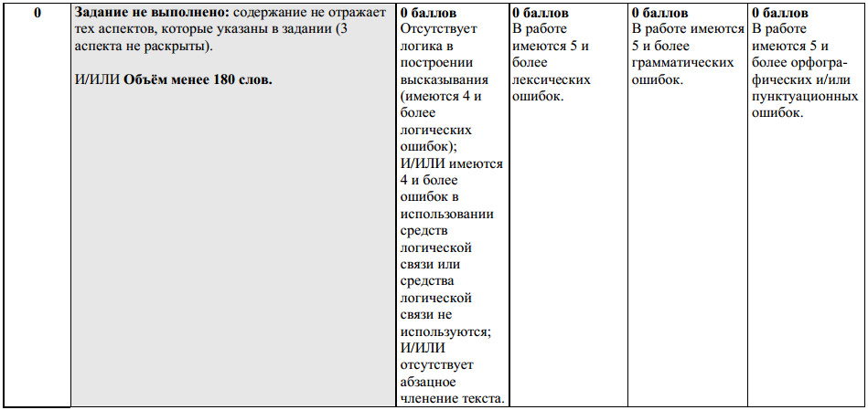

Audioscript
Listening comprehension
For items 1–10 listen to a man talking about a boy called Michael who crossed the Atlantic in a sailing boat and decide whether the statements 1–10 are TRUE according to the text you hear (A), or FALSE (B), or the information on the statement is NOT STATED in the text (C). You will hear the text twice. You have 20 seconds to look through the statements.
(pause 20 seconds)
Now we begin
In 2007, Michael Perham, a fourteen-year-old boy from the south of England, became the youngest person to sail across the Atlantic alone. Michael set off from Gibraltar on the 5,600 kilometre voyage which took forty-seven days. It was a long and, some may say, dangerous adventure, but Michael was determined to get there.
Michael started sailing when he was seven, and says the idea of an Atlantic crossing had been floating around in his head for a few years. Then one day, his father, Peter, who’s a keen sailor, decided that the time was right. Michael helped with the design of a new 9-metre yacht which was built for them and to which Michael gave the name the Cheeky Monkey.
They say that for a real sailor, crossing the Atlantic isn’t a big deal, but people imagine that sharks and huge waves would be the greatest dangers. In fact, Michael’s father sailed alongside his son in his own boat to make sure he was OK. They worked in shifts throughout the night: an hour on, then an hour off, because one of them had to be on watch, in case large ships came too near to them.
Are you wondering what Michael ate during his voyage? Well, he says he and his father filled two supermarket trolleys with things like sausages, spaghetti and stews, which could be easily heated in a pan. Everything had to be in tins, though, because that type of food keeps fresher than stuff in packets or jars.
So what did Michael miss most? He says he sometimes missed human contact and having a face-to-face conversation. He got used to his limited food supply but says what he really longed for was hot toast. Knowing what teenagers are like, I’d been expecting him to say burgers or crisps, but then Michael is no ordinary teenager!
When asked how he communicated with his father, Michael explains that it was all done by radio, though for Michael nothing compared with the pleasure of following his father’s progress through his binoculars. Michael also communicated with his family at home by satellite phone. One day his father contacted Michael to tell him a part of his own boat was broken, which really disappointed Michael because it might mean that they would have to go slower. But, in the end, that wasn’t necessary.
I asked Michael how he entertained himself on the boat. He told me he’d taken his guitar with him but it had stayed in its case throughout the trip. He couldn’t play because the boat was always rolling about! He loved to read and he also had an iPod that his sister had lent him. This he plugged into portable speakers and it was on pretty much all the time.
Was there anything that frightened Michael? He says the weather was a bit of a worry at times, and once he got caught in a force-nine storm, but managed to handle the boat OK. The one event that really shook him was when a flying fish jumped into the boat and hit him on the shoulder. But mostly things were great, like sailing alongside dolphins and seeing the bluest skies anyone could ever imagine.
Everybody is really proud of Michael’s achievements. And a remarkable thing about the trip is that he also raised thousands of pounds for the charity known as ‘Children in Need’. His school has been very supportive — the head teacher allowed Michael to miss school, saying that a few weeks on the ocean would be an amazing learning experience.
It’s quite likely that Michael’s next challenge will be to sail non-stop around the world. His father would do the trip in another boat, but it would be a very different experience because they would be in 20-metre boats which travel much faster, so they would never really be in sight of each other. Michael says next time he’ll remember to pack some photos, to remember friends and family if he feels lonely, but he’ll leave the guitar at home!
You have 20 seconds to check your answers. (pause 20 seconds)
Now listen to the text again. (text repeated)
This is the end of the listening comprehension task.

